All tutorials from https://fastapi.tiangolo.com/tutorial/

14 February 2021 – Happy Valentine’s Day !

-----------------------------------------------------------------------------------------------------------------------------

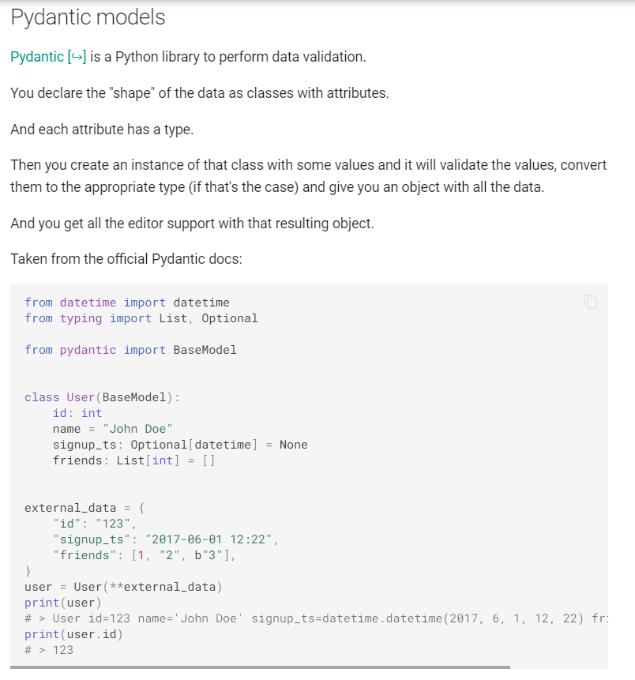

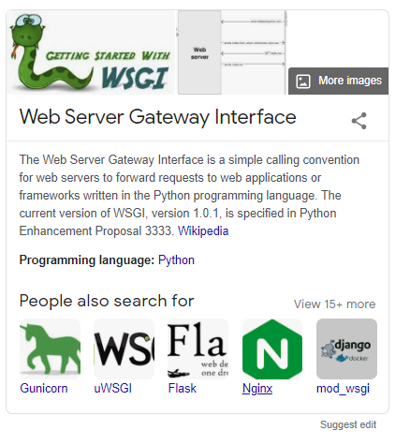

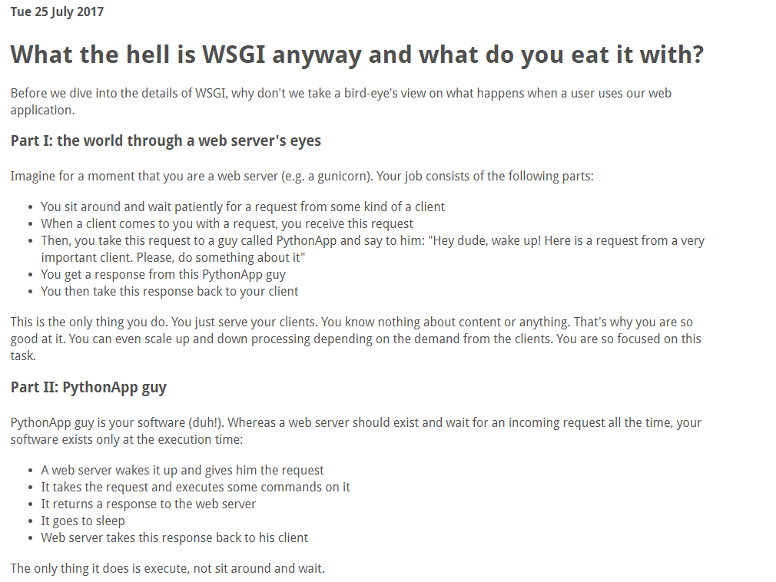

https://rahmonov.me/posts/what-the-hell-is-wsgi-anyway-and-what-do-you-eat-it-with/

